1. Added resilience4j and its two transitive dependencies (AOP, Actuator).

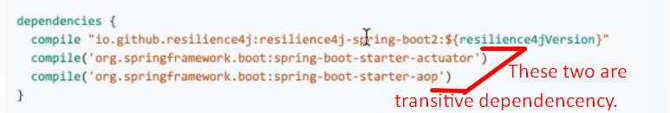



1. @Retry:  
   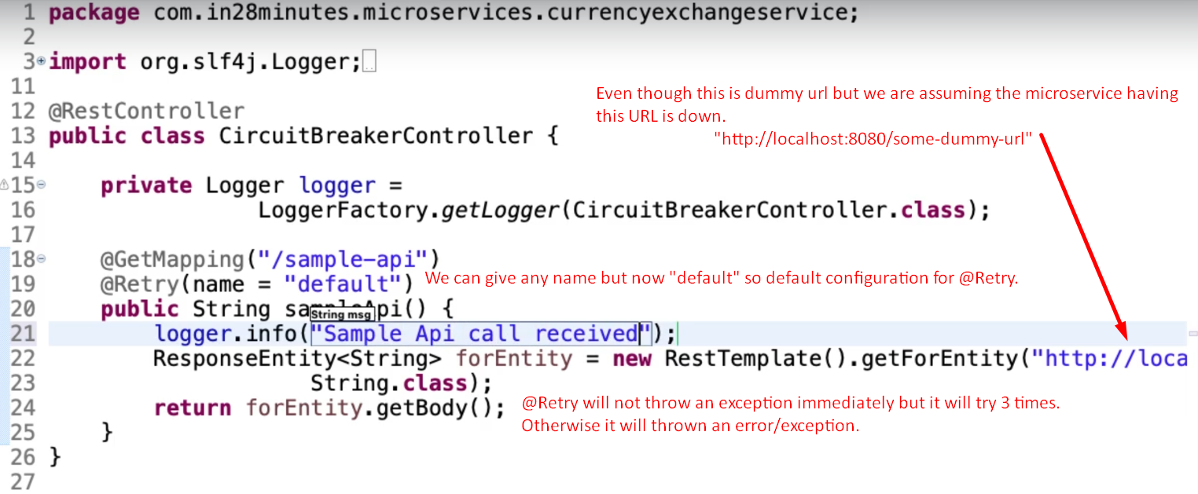NOTE: Total retry when not configuring anything is 3 times.  
   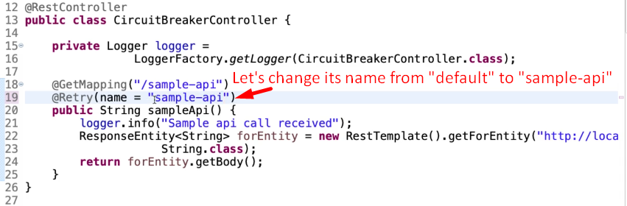
2. fallbackMethod: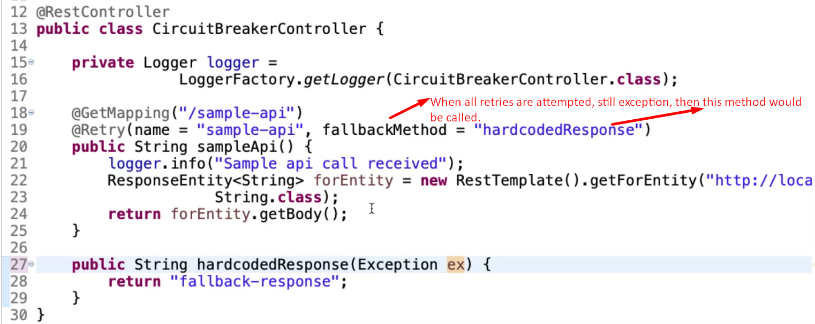
3. application.properties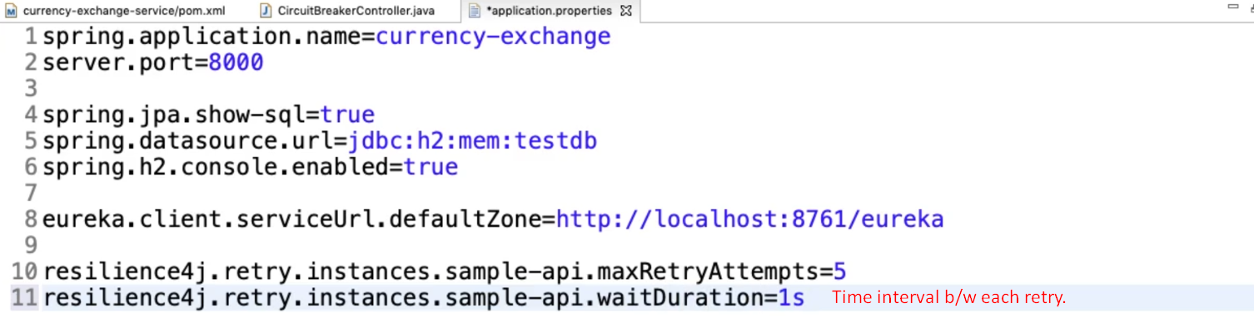
4. 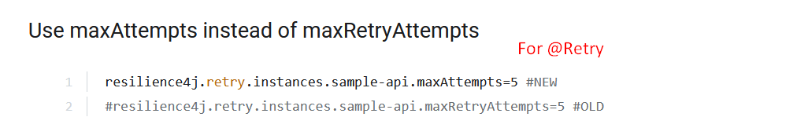
5. 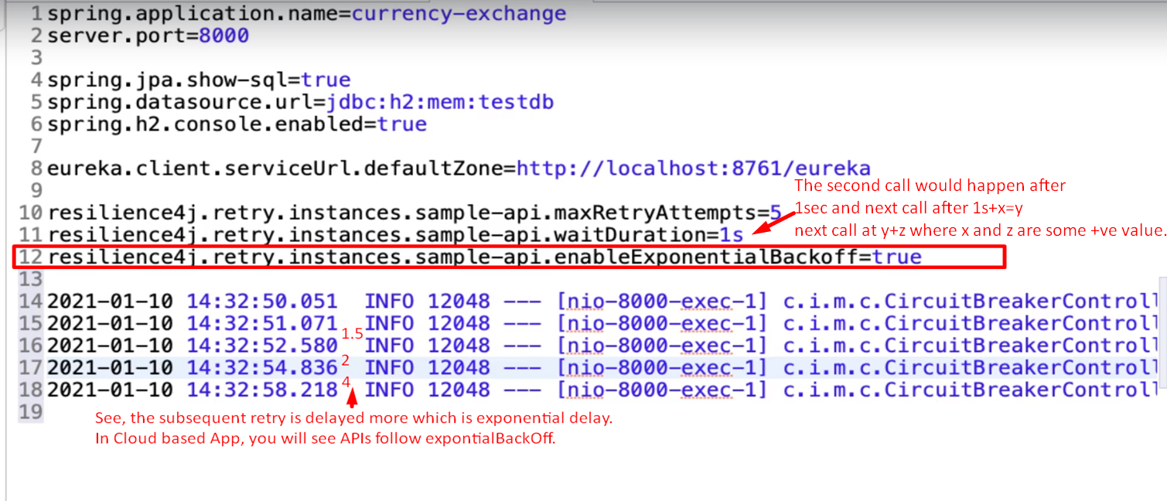

CircuitBreaker

1. 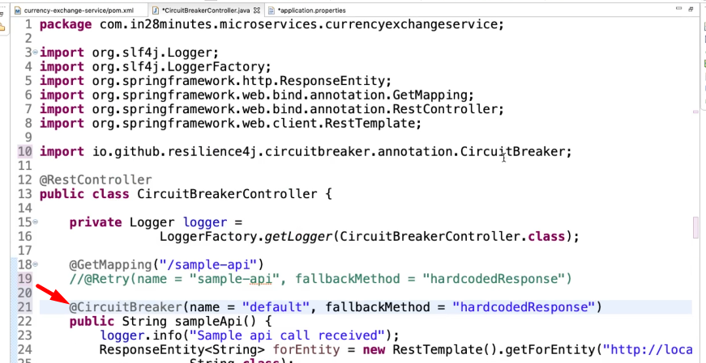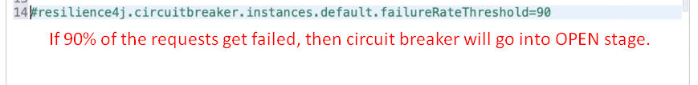

Rate Limit

1. @RateLimiter  
   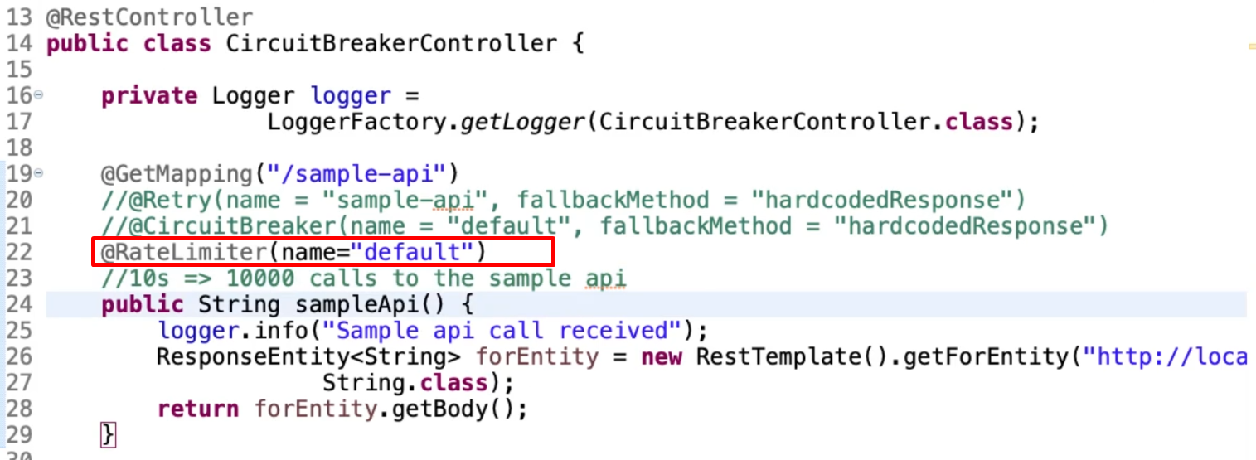
2. application.properties  
   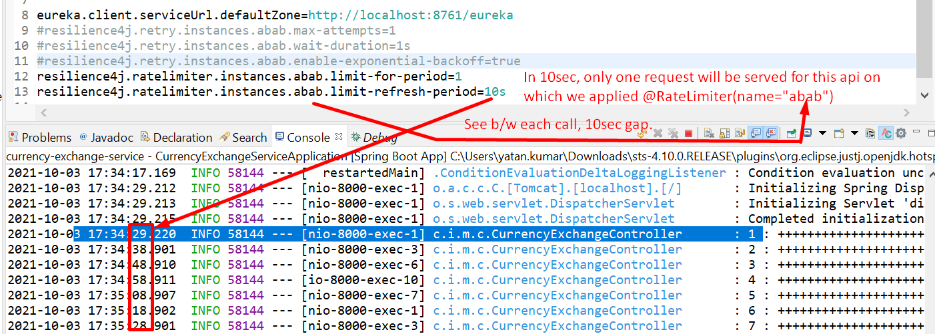

Bulkhead

1. 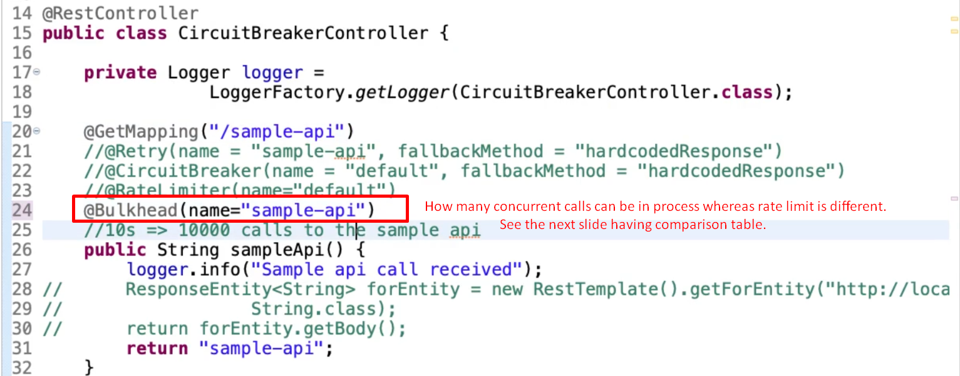
2. 